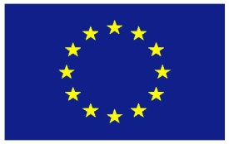

**EU Statement**

**Matters pertaining to Financial Contributions**

**Arms Trade Treaty**

**Tenth Conference of States Parties**

**Geneva, 19-23 August 2024**

Mr. President,

I have the honour to speak on behalf of the European Union and its Member States.

**The candidate countries Türkiye, North Macedonia, Montenegro, Serbia, Albania, Republic of Moldova, Bosnia and Herzegovina**[1] **and Georgia, as well as the EFTA country Norway, member of the European Economic Area, align themselves with this statement.**

The EU thanks the ATT Secretariat for the overview of the financial situation.

As in previous years, the EU would like to express its deep concern over the unfavourable financial situation of the ATT. It is of crucial importance that the effective functioning of the Treaty and its institutions is preserved, and that the accumulation of arrears does not put ATT activities at risk. Once again, we urge all States to pay their contributions in full and on time. The Financial Rules of the Treaty must be respected by all States Parties, signatories and observers. The EU, as a significant financial contributor to ATT activities, insists on ensuring the necessary arrangements for States in arrears to settle their financial obligations at the shortest possible notice. With this in mind, we strongly encourage States that are in arrears to consider agreeing on a payment plan with the Secretariat, in line with rule 8.1 (d) of the Treaty’s Financial Rules. This will lead to increased financial, and subsequently institutional, stability of the Treaty.

Thank you, Mr. President

1. **North Macedonia, Montenegro, Serbia, Albania and Bosnia and Herzegovina continue to be part of the Stabilisation and Association Process.**